**Summary of project**

My project is an online article share website. I just mimic a really word of the blog website to create this final project. This website can connect people , which means you can follow others and be followed by others . So, it represents the connected internet.

**Functionality**

I have two roles in this website. One is for users, one is for administrators. As an user , you can do some inspiration this like crate article and upload the picture of this article which need to check security. Then, there will be an article station for users which gathers all articles uploaded on this website. And you can do search and classify the articles you want to search. Then , user an explore the others to follow and unfollow. Each user will has their own station whose articles created by themselves and they have their own homepage whose articles are themselves and people they followed. Plus, user can favorite the articles and comment for articles.

As an admin role, you can mange articles like delete article or comment , but you need to check the security of this function. And admin can block the user to make them can not login.

**Technologies**

Ajax, spring security(authorization and authentication), xml filter, pagination, criteria , bootstrap, validator, exception and annotation

Screenshots



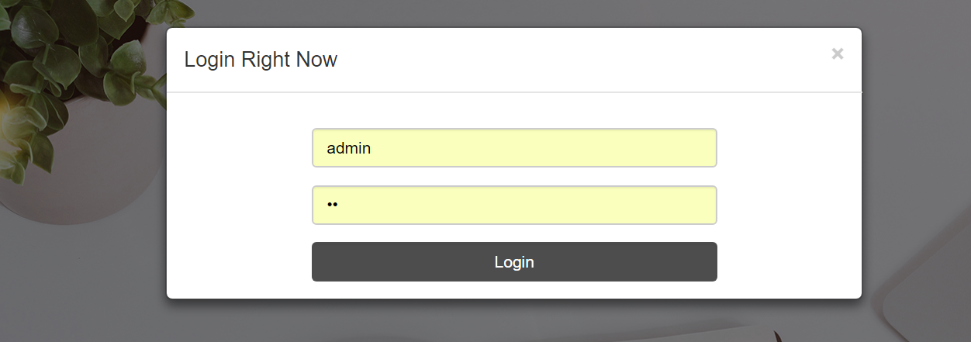

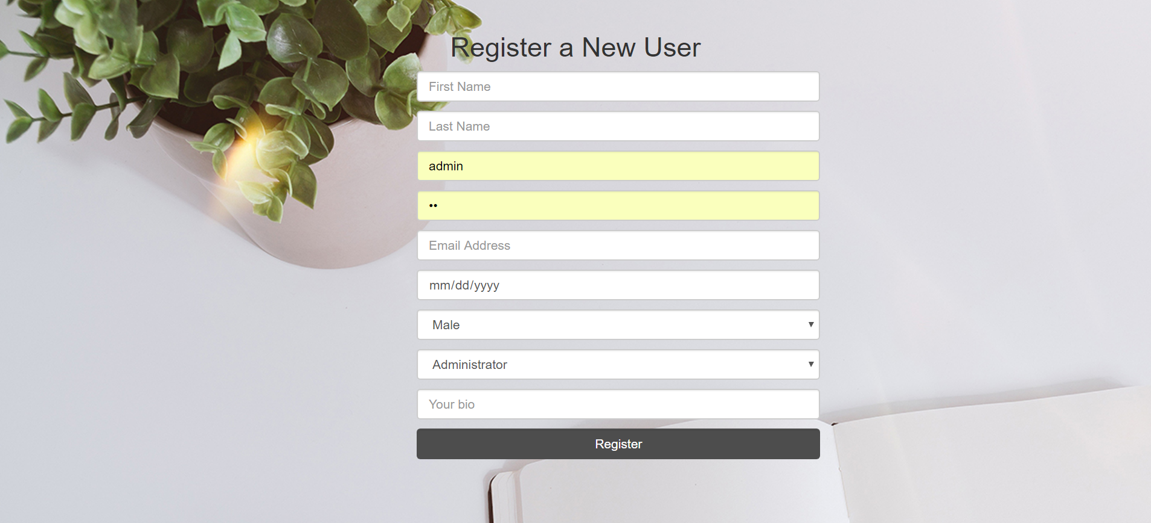 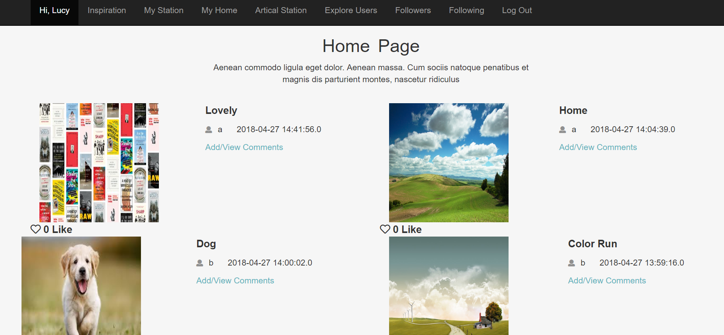

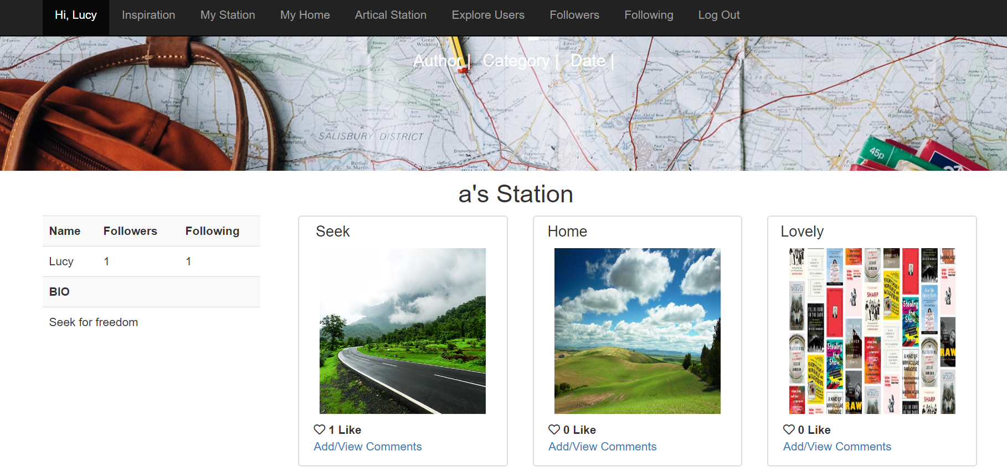



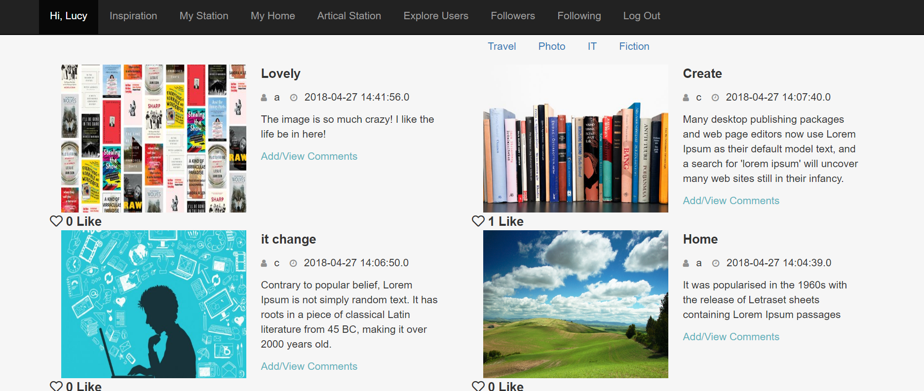

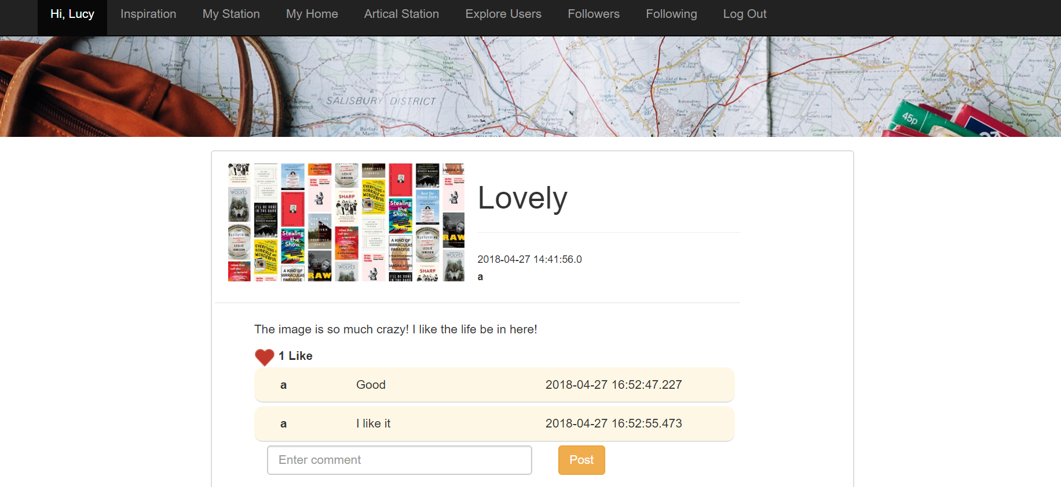

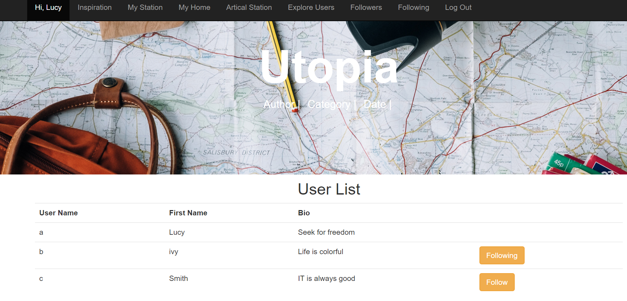

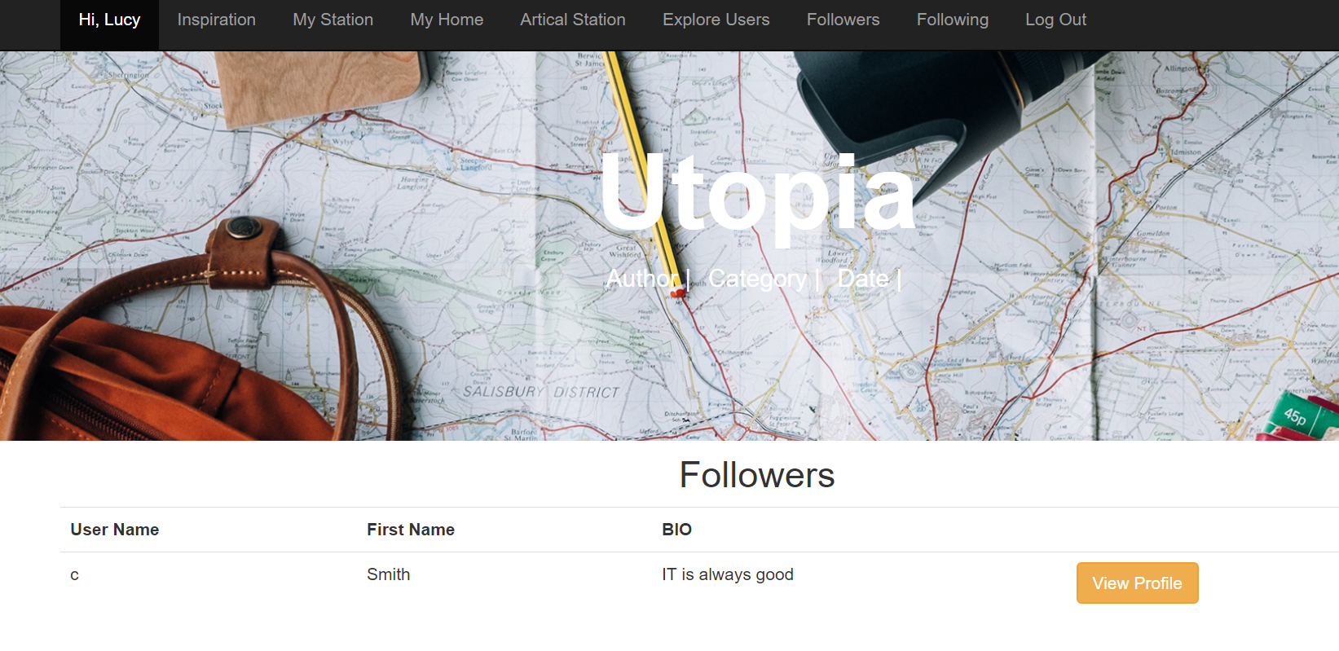

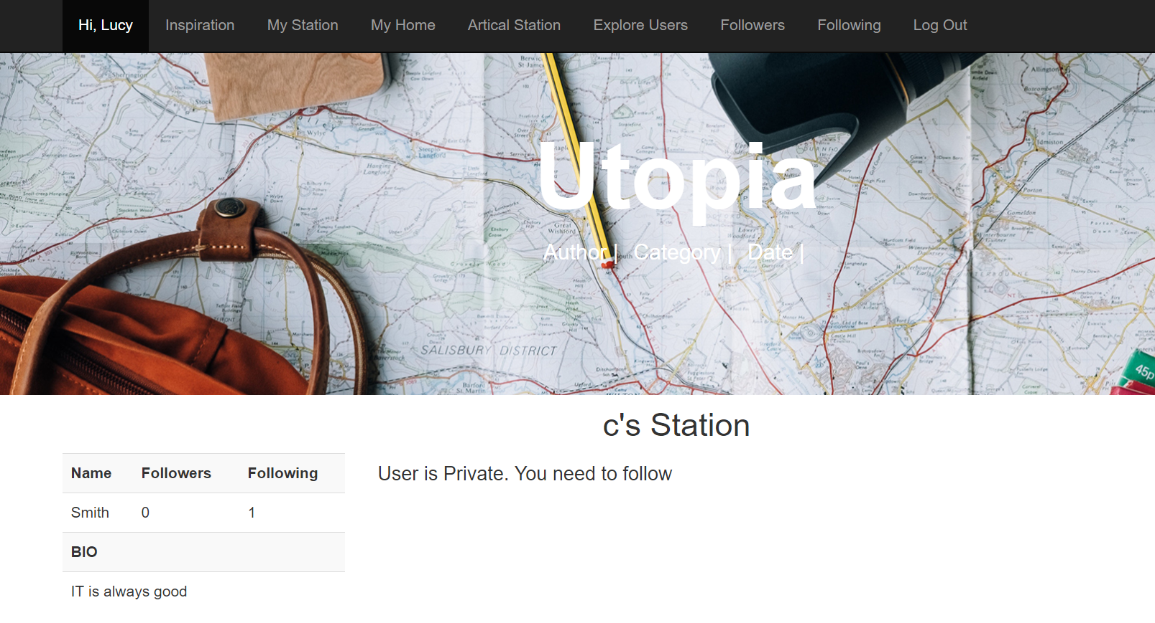

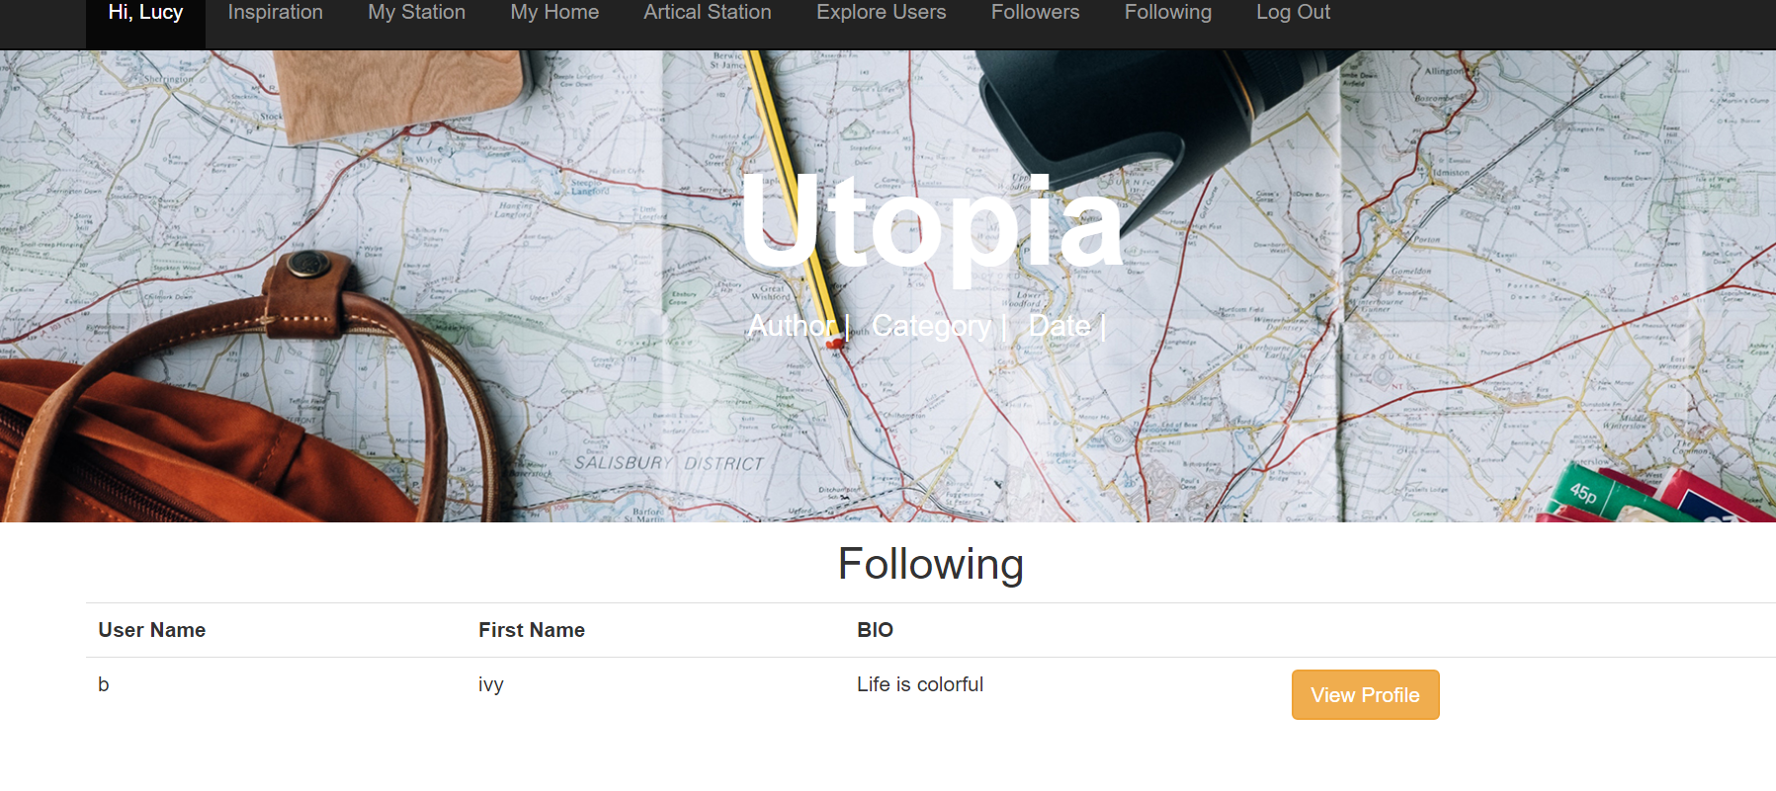

Admin role

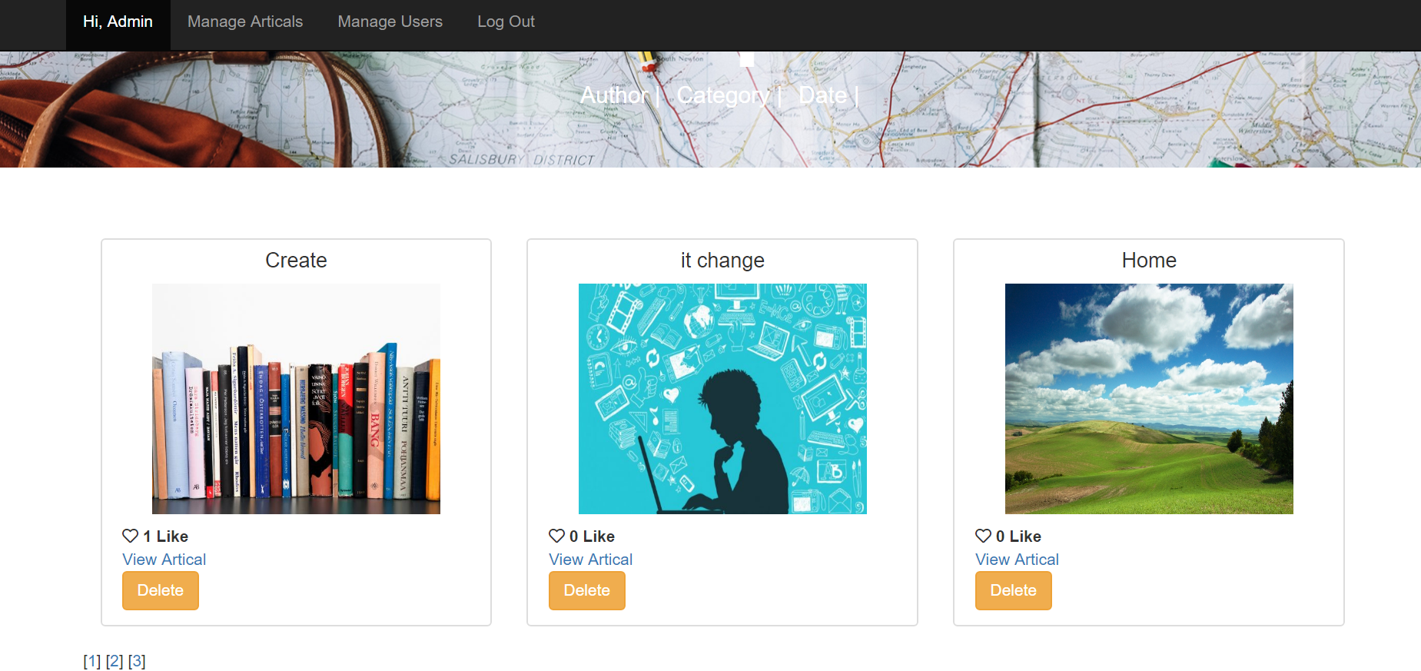

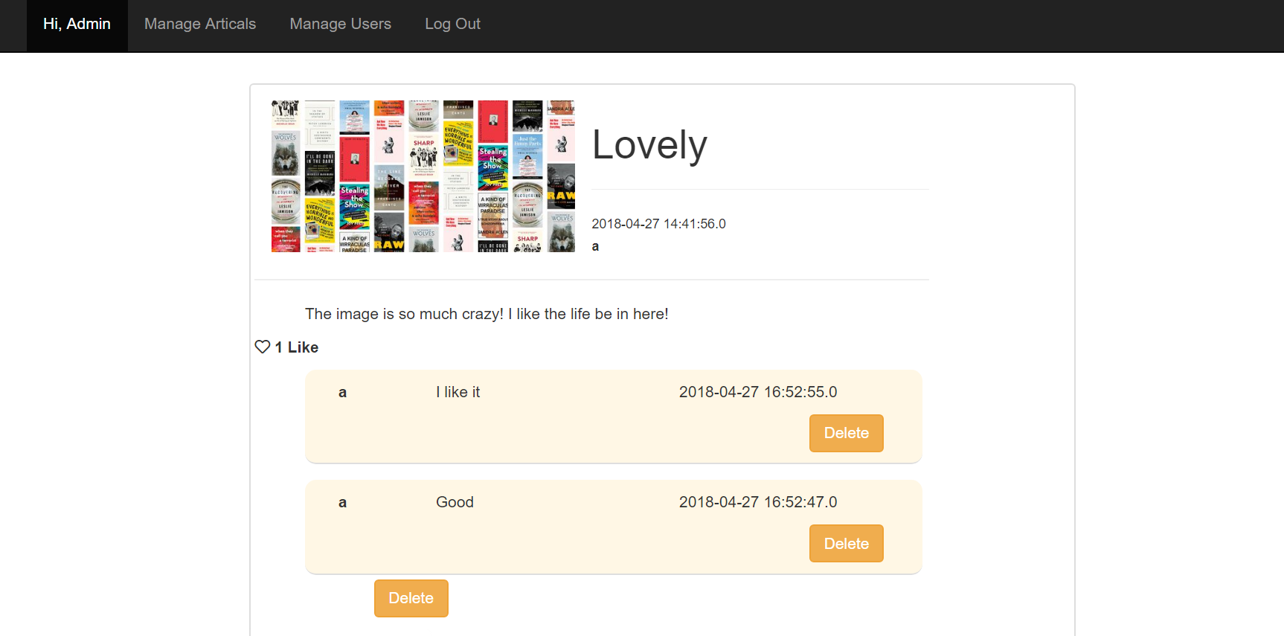

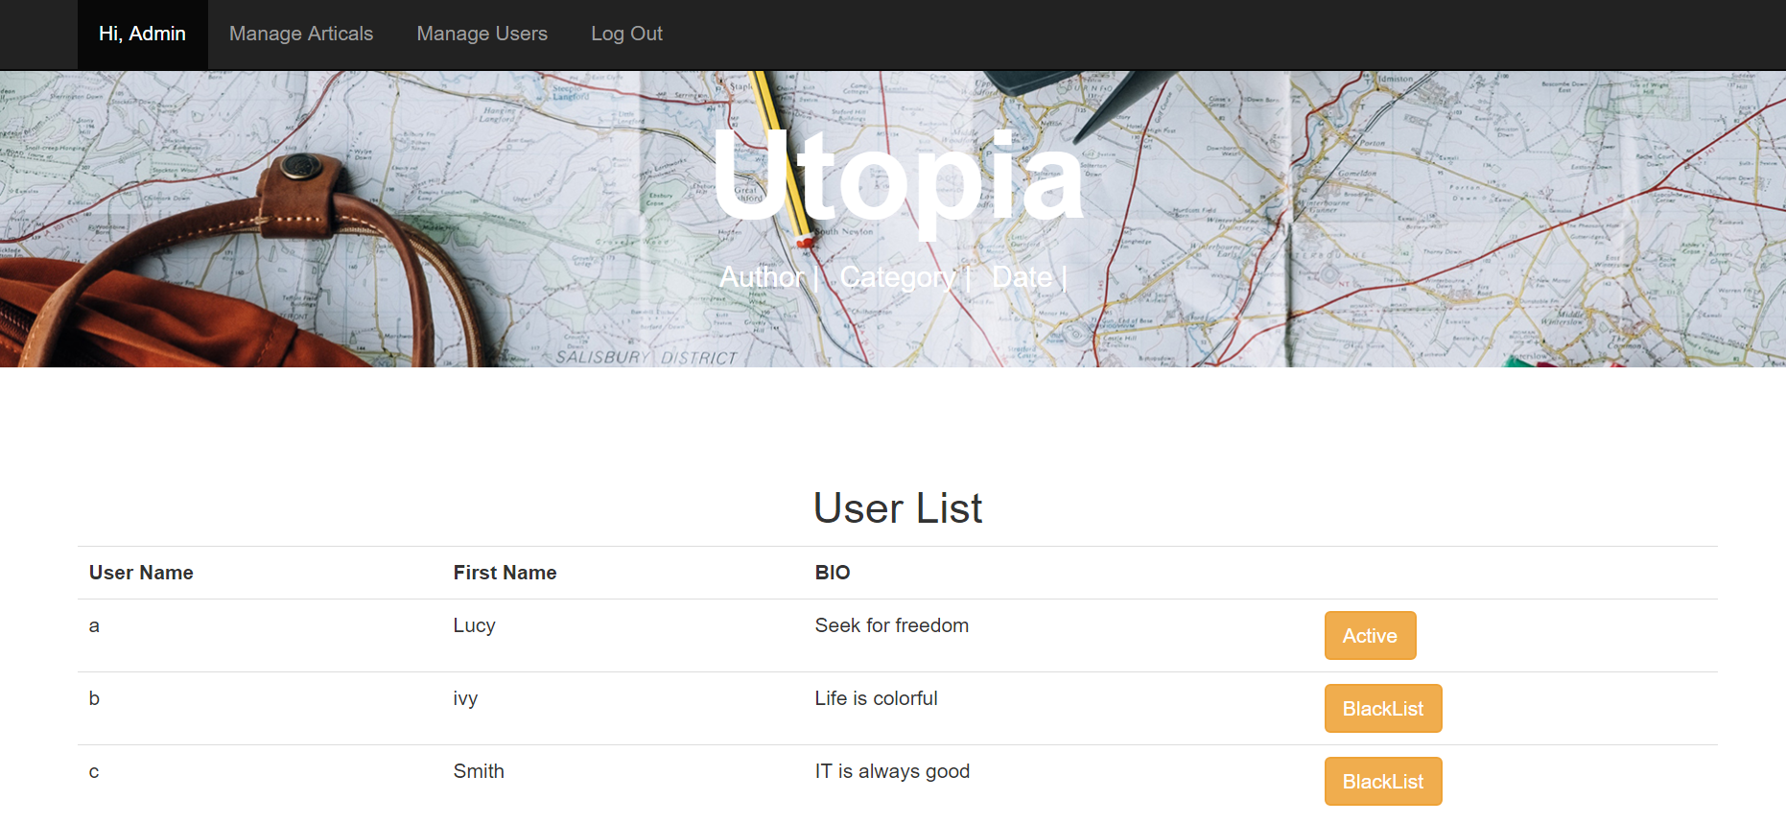

**Security**

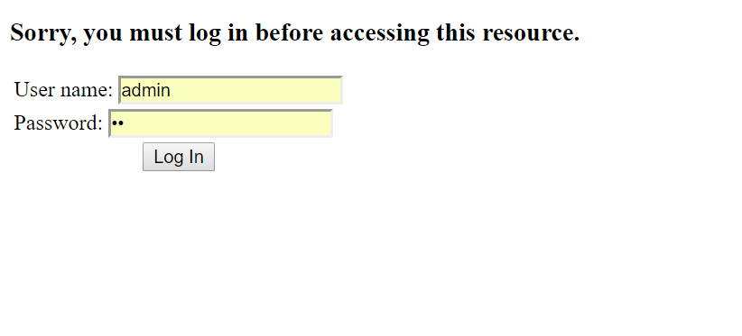

**Source code**

package com.me.myweb.controller;

import java.util.ArrayList;

import java.util.Collections;

import java.util.Comparator;

import java.util.Date;

import java.util.HashMap;

import java.util.List;

import java.util.Map;

import javax.servlet.http.HttpServletRequest;

import javax.servlet.http.HttpSession;

import org.springframework.beans.factory.annotation.Autowired;

import org.springframework.beans.factory.annotation.Qualifier;

import org.springframework.stereotype.Controller;

import org.springframework.web.bind.WebDataBinder;

import org.springframework.web.bind.annotation.InitBinder;

import org.springframework.web.bind.annotation.PathVariable;

import org.springframework.web.bind.annotation.RequestMapping;

import org.springframework.web.bind.annotation.RequestMethod;

import org.springframework.web.bind.annotation.RequestParam;

import org.springframework.web.bind.annotation.ResponseBody;

import org.springframework.web.servlet.ModelAndView;

import com.me.myweb.dao.ArticalDAO;

import com.me.myweb.dao.FollowerDAO;

import com.me.myweb.dao.UserDAO;

import com.me.myweb.exception.FollowerException;

import com.me.myweb.exception.UserException;

import com.me.myweb.pojo.Artical;

import com.me.myweb.pojo.Comment;

import com.me.myweb.pojo.Favorite;

import com.me.myweb.pojo.User;

import com.me.myweb.valarticalIdator.UserValarticalIdator;

@Controller

public class AdministratorController {

@Autowired

@Qualifier("userDao")

UserDAO userDao;

@Autowired

@Qualifier("followerDao")

FollowerDAO followerDao;

@Autowired

@Qualifier("articalDao")

ArticalDAO articalDao;

@Autowired

@Qualifier("userValarticalIdator")

UserValarticalIdator valarticalIdator;

@InitBinder

private voarticalId initBinder(WebDataBinder binder) {

binder.setValarticalIdator(valarticalIdator);

}

@RequestMapping(value = "/user/manage", method = RequestMethod.GET)

protected ModelAndView manageUser() throws Exception {

List<Boolean> status = new ArrayList<Boolean>();

List<User> userList = null;

Map<String, Object> model = new HashMap<String, Object>();

userList = userDao.retrieveUserList();

for (User user : userList) {

if (isBlock(user)) {

status.add(true);

} else {

status.add(false);

}

}

model.put("userlist", userList);

model.put("statuslist", status);

return new ModelAndView("manage_users", "model",model);

}

public boolean isBlock(User u) throws UserException {

boolean flag = false;

if(userDao.checkStatus(u))

flag=false;

else {

flag=true;

}

return flag;

}

@RequestMapping(value = "/blacklist/add", method = RequestMethod.POST, produces = "application/json")

@ResponseBody

public boolean switchFollower(HttpServletRequest request, @RequestParam String personarticalId) throws Exception {

System.*out*.println("reached controller");

boolean flag = false;

int articalId = Integer.*parseInt*(personarticalId);

User user = (User) userDao.get(articalId);

if (isBlock(user)) {

flag = userDao.removeBlock(user);

} else {

flag = userDao.addBlock(user);

}

return flag;

}

@RequestMapping(value = "/artical/manage", method = RequestMethod.GET)

protected ModelAndView manageArtical() throws Exception {

List<Artical> articalList =articalDao.getpage(0);

Collections.*sort*(articalList, new Comparator<Artical>() {

public int compare(Artical a1, Artical a2) {

return a2.getUploadDate().compareTo(a1.getUploadDate());

}

});

return new ModelAndView("manage_articals", "articals", articalList);

}

@RequestMapping(value = "/artical/managepage", method = RequestMethod.GET)

protected ModelAndView page(HttpServletRequest request) throws Exception {

String i =request.getParameter("page");

int number=Integer.*parseInt*(i);

List<Artical> articalList =articalDao.getpage(number);

System.*out*.println("articalSize------"+articalList.size());

Collections.*sort*(articalList, new Comparator<Artical>() {

public int compare(Artical a1, Artical a2) {

return a2.getUploadDate().compareTo(a1.getUploadDate());

}

});

return new ModelAndView("manage_articals", "articals", articalList);

}

@RequestMapping(value = "/artical/delete", method = RequestMethod.GET)

protected ModelAndView deleteArtical(HttpServletRequest request) throws Exception {

long articalId =Long.*parseLong*(request.getParameter("delete"));

Artical artical = articalDao.getArtical(articalId);

articalDao.delete(artical);

List<Artical> articalList = articalDao.getAllArticals();

Collections.*sort*(articalList, new Comparator<Artical>() {

public int compare(Artical a1, Artical a2) {

return a2.getUploadDate().compareTo(a1.getUploadDate());

}

});

return new ModelAndView("manage_articals", "articals", articalList);

}

@RequestMapping(value = "/artical/view/{articalId}", method = RequestMethod.GET)

protected ModelAndView viewPost(HttpServletRequest request, @PathVariable("articalId") String articalId) throws Exception {

long articalId = Long.*parseLong*(articalId);

boolean flag;

Map<String, Object> map = new HashMap<String, Object>();

Artical artical = articalDao.getArtical(articalId);

HttpSession session = request.getSession();

User u = (User) session.getAttribute("user");

Favorite l = articalDao.doesFavorites(u, artical);

List<Comment> comments = articalDao.getArticalComments(articalId);

Collections.*sort*(comments, new Comparator<Comment>() {

public int compare(Comment a1, Comment a2) {

return a2.getCommentTime().compareTo(a1.getCommentTime());

}

});

if (l != null)

flag = true;

else

flag = false;

map.put("flag", flag);

map.put("artical", artical);

map.put("comments", comments);

map.put("count", articalDao.countFavorite(articalId));

return new ModelAndView("administrator_post_view", "map", map);

}

@RequestMapping(value = "/comment/delete", method = RequestMethod.GET)

protected ModelAndView deleteComment(HttpServletRequest request) throws Exception {

long articalId =Long.*parseLong*(request.getParameter("delete"));

String articalId=request.getParameter("articalId");

Comment comment = articalDao.getComment(articalId);

articalDao.deleteComment(comment);

ModelAndView mav =new ModelAndView();

mav=viewPost(request,articalId);

System.*out*.println("fdggfg");

return mav;

}

}

package com.me.myweb.controller;

import java.io.File;

import java.io.IOException;

import java.math.BigInteger;

import java.text.SimpleDateFormat;

import java.util.ArrayList;

import java.util.Collections;

import java.util.Comparator;

import java.util.Date;

import java.util.HashMap;

import java.util.List;

import java.util.Map;

import javax.servlet.http.HttpServletRequest;

import javax.servlet.http.HttpSession;

import org.springframework.beans.factory.annotation.Autowired;

import org.springframework.beans.factory.annotation.Qualifier;

import org.springframework.stereotype.Controller;

import org.springframework.ui.ModelMap;

import org.springframework.web.bind.annotation.ModelAttribute;

import org.springframework.web.bind.annotation.Variable;

import org.springframework.web.bind.annotation.RequestMapping;

import org.springframework.web.bind.annotation.RequestMethod;

import org.springframework.web.bind.annotation.RequestParam;

import org.springframework.web.bind.annotation.ResponseBody;

import org.springframework.web.multipart.commons.CommonsMultipartFile;

import org.springframework.web.servlet.ModelAndView;

import com.me.myweb.dao.ArticalDAO;

import com.me.myweb.dao.FollowerDAO;

import com.me.myweb.dao.UserDAO;

import com.me.myweb.exception.ArticalException;

import com.me.myweb.exception.FollowerException;

import com.me.myweb.exception.UserException;

import com.me.myweb.pojo.Artical;

import com.me.myweb.pojo.Comment;

import com.me.myweb.pojo.Favorite;

import com.me.myweb.pojo.User;

import com.me.myweb.utils.JsonUtils;

@Controller

public class ArticalController {

@Autowired

@Qualifier("articalDao")

ArticalDAO articalDao;

@Autowired

@Qualifier("userDao")

UserDAO userDao;

@Autowired

@Qualifier("followerDao")

FollowerDAO followerDao;

@RequestMapping(value = "/artical/create", method = RequestMethod.GET)

public String showForm(ModelMap model) {

Artical artical =new Artical();

model.addAttribute("artical", artical);

return "artical_create";

}

@RequestMapping(value = "/artical/upload", method = RequestMethod.POST)

public ModelAndView handleUpload(@ModelAttribute("artical") Artical artical, HttpServletRequest request) throws Exception {

ModelAndView mv = null;

try {

HttpSession session = (HttpSession) request.getSession();

User u = (User) session.getAttribute("user");

String slash = "/";

String path = slash + "user_images_" + u.getPersonID();

File pathectory;

String = "F:/SpringProjects/Final_WebTools/src/main/webapp/resources/images";

String content =request.getParameter("content");

String articalName = request.getParameter("articalName");

String type =request.getParameter("type");

+= path;

pathectory = new File();

boolean temp = pathectory.exists();

if (!temp) {

temp = pathectory.mkpath();

}

if (temp) {

CommonsMultipartFile articalInMemory = artical.getPic();

System.*out*.print(articalInMemory);

String fileName = articalInMemory.getOriginalFilename();

System.*out*.print(fileName);

File localFile = new File(pathectory.get(), fileName);

articalInMemory.transferTo(localFile);

String imageName = slash + "images" + path + slash + fileName;

artical.setFileName(imageName);

artical.setArticalName(articalName);

artical.setContent(content);

artical.setType(type);

artical.setUser(u);

artical.setUploadDate(new Date());

Artical p = articalDao.upload(artical);

mv =allArticals(request);

} else {

System.*out*.println("Failed to create pathectory!");

}

} catch (IllegalStateException e) {

System.*out*.println("*** IllegalStateException: " + e.getMessage());

} catch (IOException e) {

// TODO Auto-generated catch block

System.*out*.println("*** IOException: " + e.getMessage());

} catch (ArticalException e) {

// TODO Auto-generated catch block

e.printStackTrace();

}

return mv;

}

@RequestMapping(value = "/artical/station", method = RequestMethod.GET)

public ModelAndView allArticals(HttpServletRequest request) throws ArticalException {

List<Artical> articalList = articalDao.getAllArticals();

Collections.*sort*(articalList, new Comparator<Artical>() {

public int compare(Artical a1, Artical a2) {

return a2.getUploadDate().compareTo(a1.getUploadDate());

}

});

return new ModelAndView("artical_station", "articals", articalList);

}

@RequestMapping(value = "/artical/search", method = RequestMethod.POST)

public ModelAndView searchArticals(HttpServletRequest request) throws ArticalException {

String search =request.getParameter("search");

List<Artical> articalList = articalDao.search(search);

Collections.*sort*(articalList, new Comparator<Artical>() {

public int compare(Artical a1, Artical a2) {

return a2.getUploadDate().compareTo(a1.getUploadDate());

}

});

return new ModelAndView("artical_station", "articals", articalList);

}

@RequestMapping(value = "/artical/type", method = RequestMethod.GET)

public ModelAndView classifyArticals(HttpServletRequest request) throws ArticalException {

String search =request.getParameter("name");

List<Artical> articalList = articalDao.type(search);

Collections.*sort*(articalList, new Comparator<Artical>() {

public int compare(Artical a1, Artical a2) {

return a2.getUploadDate().compareTo(a1.getUploadDate());

}

});

return new ModelAndView("artical_station", "articals", articalList);

}

@RequestMapping(value = "/user/station", method = RequestMethod.GET)

public ModelAndView retriveArticals(HttpServletRequest request) throws FollowerException {

Map<String, Object> model = new HashMap<String, Object>();

List<Artical> artical_list = null;

List<User> subscribers = null;

HttpSession session = request.getSession();

User u = (User) session.getAttribute("user");

try {

subscribers = subscribersList(u);

artical_list = articalDao.get(u);

} catch (ArticalException e) {

// TODO Auto-generated catch block

e.printStackTrace();

} catch (UserException e) {

// TODO Auto-generated catch block

e.printStackTrace();

}

model.put("artical_list", artical_list);

model.put("subscribers", subscribers);

return new ModelAndView("user_station", "model", model);

}

@RequestMapping(value = "/artical/add", method = RequestMethod.POST, produces = "application/json")

@ResponseBody

public String favoriteUnfavorite(HttpServletRequest request, @RequestParam String articalID) throws Exception {

boolean flag;

HttpSession session = request.getSession();

long id = Long.*parseLong*(articalID);

User u = (User) session.getAttribute("user");

Artical a = articalDao.getArtical(id);

Favorite l = articalDao.doesFavorites(u, a);

if (l == null) {

Favorite favorite = new Favorite();

favorite.setFavoriteArtical(a);

favorite.setUser(u);

a.setFavoriteCount(a.getFavoriteCount()+1);

articalDao.registerLike(favorite);

flag = true;

} else {

a.setFavoriteCount(a.getFavoriteCount()-1);

articalDao.removeFavorite(l);

flag = false;

}

String result = "{" + JsonUtils.toJsonField("flag", String.*valueOf*(flag))

+ (", " + JsonUtils.toJsonField("count", String.*valueOf*(a.getFavorite().size()))) + "}";

return result;

}

@RequestMapping(value = "/artical/comment/{commentid}", method = RequestMethod.GET)

protected ModelAndView viewPost(HttpServletRequest request, @Variable("commentid") String id) throws Exception {

long articalID = Long.*parseLong*(commentid);

boolean flag;

Map<String, Object> map = new HashMap<String, Object>();

Artical artical = articalDao.getArtical(articalID);

HttpSession session = request.getSession();

User u = (User) session.getAttribute("user");

Favorite l = articalDao.doesFavorites(u, artical);

List<Comment> comments = articalDao.getArticalComments(articalID);

if (l != null)

flag = true;

else

flag = false;

map.put("flag", flag);

map.put("artical", artical);

map.put("comments", comments);

map.put("count", articalDao.countFavorite(articalID));

return new ModelAndView("post_view", "map", map);

}

@RequestMapping(value = "/artical/comment/add", method = RequestMethod.POST, produces = "application/json")

@ResponseBody

public String addComment(HttpServletRequest request, @RequestParam String comText, @RequestParam String articalID)

throws Exception {

long artiID = Long.*parseLong*(articalID);

Artical artical = articalDao.getArtical(artiID);

HttpSession session = request.getSession();

User user = (User) session.getAttribute("user");

Comment com = new Comment();

com.setUser(user);

com.setCommentContent(comText);

com.setCommentArtical(artical);

com.setCommentTime(new Date());

articalDao.addComment(com);

SimpleDateFormat formatter = new SimpleDateFormat("yyyy-MM-dd HH:mm:ss.S");

String s =formatter.format(com.getCommentTime());

System.*out*.println("added comment");

String result = "{" + JsonUtils.toJsonField("user", com.getUser().getUsername())

+ (", " + JsonUtils.toJsonField("comment", com.getCommentContent()))

+ (", " + JsonUtils.toJsonField("time", s))+"}";

return result;

}

@RequestMapping(value = "/user/favorite", method = RequestMethod.POST)

@ResponseBody

public long favoriteCounter(HttpServletRequest request, @RequestParam String articalID) {

System.*out*.println("reached");

long count = 0;

try {

count = articalDao.increment(articalID);

} catch (ArticalException e) {

// TODO Auto-generated catch block

e.printStackTrace();

}

return count;

}

public List<User> subscribersList(User user) throws UserException, FollowerException {

List<User> subscribers = new ArrayList<User>();

if(followerDao.retrievesubscribers(user).isEmpty())

{

subscribers=null;

}

else {

for(BigInteger i: followerDao.retrievesubscribers(user))

{

for(User u:userDao.retrieveUserList()) {

if(u.getPersonID()==i.longValue()) {

subscribers.add(u);

}

}

}

}

return subscribers;

}

}

package com.me.myweb.controller;

import java.math.BigInteger;

import java.util.ArrayList;

import java.util.HashMap;

import java.util.List;

import java.util.Map;

import javax.servlet.http.HttpServletRequest;

import javax.servlet.http.HttpSession;

import org.springframework.beans.factory.annotation.Autowired;

import org.springframework.beans.factory.annotation.Qualifier;

import org.springframework.stereotype.Controller;

import org.springframework.web.bind.annotation.PathVariable;

import org.springframework.web.bind.annotation.RequestMapping;

import org.springframework.web.bind.annotation.RequestMethod;

import org.springframework.web.bind.annotation.RequestParam;

import org.springframework.web.bind.annotation.ResponseBody;

import org.springframework.web.servlet.ModelAndView;

import com.me.myweb.dao.FollowerDAO;

import com.me.myweb.dao.UserDAO;

import com.me.myweb.exception.FollowerException;

import com.me.myweb.exception.UserException;

import com.me.myweb.pojo.User;

@Controller

public class FollowerController {

@Autowired

@Qualifier("userDao")

UserDAO userDao;

@Autowired

@Qualifier("followerDao")

FollowerDAO followerDao;

@RequestMapping(value = "/follow/add", method = RequestMethod.POST, produces = "application/json")

@ResponseBody

public boolean switchFollower(HttpServletRequest request, @RequestParam String suscriberID) throws Exception {

boolean pit = false;

int id = Integer.parseInt(suscriberID);

HttpSession session = request.getSession();

User follower = (User) session.getAttribute("user");

try {

User suscriber = (User) followerDao.get(id);

if (isPresent(suscriber, follower)) {

pit = followerDao.deleteFollower(suscriber,follower);

} else {

pit = followerDao.addFollower(suscriber,follower);

}

} catch (FollowerException e) {

// TODO Auto-generated catch block

e.printStackTrace();

}

return pit;

}

public boolean isPresent(User user, User follower) throws UserException, FollowerException {

boolean pit = false;

for (BigInteger b: followerDao.getFollowers(user)) {

for(User u: userDao.retrieveUserList())

{ if(u.getPersonID()==b.longValue()&&u.getPersonID()==follower.getPersonID())

{

pit = true;

break;

}

}

}

return pit;

}

@RequestMapping(value = "/follow/followers", method = RequestMethod.GET)

protected ModelAndView getFollowers(HttpServletRequest request) throws Exception {

List<User> followerlist = null;

HttpSession session = request.getSession();

User u = (User) session.getAttribute("user");

followerlist = followersList(u);

return new ModelAndView("user_followers", "followerlist", followerlist);

}

@RequestMapping(value = "/follow/subscribers", method = RequestMethod.GET)

protected ModelAndView retrievesubscribers(HttpServletRequest request) throws Exception {

List<User> subscribers = new ArrayList<User>();

HttpSession session = request.getSession();

User user = (User) session.getAttribute("user");

subscribers = subscribersList(user);

return new ModelAndView("user_subscribers", "subscriberslist", subscribers);

}

@RequestMapping(value = "/follow/view/{personid}", method = RequestMethod.GET)

protected ModelAndView viewProfile(HttpServletRequest request, @PathVariable("personid") String id) throws Exception {

boolean pit = false;

HttpSession session = request.getSession();

User currentUser = (User) session.getAttribute("user");

List<User> subscribersList = new ArrayList<User>();

Map<String, Object> model = new HashMap<String, Object>();

int followerID = Integer.parseInt(personid);

User follower = followerDao.get(followerID);

subscribersList = subscribersList(follower);

pit=isPresent(follower,currentUser);

model.put("follower", follower);

model.put("follows", pit);

model.put("subscriberslist", subscribersList);

System.out.print("profile_view_pit"+pit);

return new ModelAndView("profile_view", "model", model);

}

public List<User> followersList(User user) throws UserException,FollowerException{

List<User> followers = new ArrayList<User>();

if(followerDao.getFollowers(user).isEmpty())

{

followers=null;

}

else {

for(BigInteger i: followerDao.getFollowers(user))

{

for(User u:userDao.retrieveUserList()) {

if(u.getPersonID()==i.longValue()) {

followers.add(u);

}

}

}

}

return followers;

}

public List<User> subscribersList(User user) throws UserException, FollowerException {

List<User> subscribers = new ArrayList<User>();

if(followerDao.retrievesubscribers(user).isEmpty())

{

subscribers=null;

}

else {

for(BigInteger i: followerDao.retrievesubscribers(user))

{

for(User u:userDao.retrieveUserList()) {

if(u.getPersonID()==i.longValue()) {

subscribers.add(u);

}

}

}

}

return subscribers;

}

}

package com.me.myweb.controller;

import java.math.BigInteger;

import java.util.ArrayList;

import java.util.Collection;

import java.util.Collections;

import java.util.Comparator;

import java.util.HashMap;

import java.util.List;

import java.util.Map;

import javax.servlet.http.HttpServletRequest;

import javax.servlet.http.HttpSession;

import org.springframework.beans.factory.annotation.Autowired;

import org.springframework.beans.factory.annotation.Qualifier;

import org.springframework.stereotype.Controller;

import org.springframework.validation.BindingResult;

import org.springframework.web.bind.WebDataBinder;

import org.springframework.web.bind.annotation.InitBinder;

import org.springframework.web.bind.annotation.ModelAttribute;

import org.springframework.web.bind.annotation.RequestMapping;

import org.springframework.web.bind.annotation.RequestMethod;

import org.springframework.web.servlet.ModelAndView;

import com.me.myweb.dao.ArticalDAO;

import com.me.myweb.dao.FollowerDAO;

import com.me.myweb.dao.UserDAO;

import com.me.myweb.exception.FollowerException;

import com.me.myweb.exception.UserException;

import com.me.myweb.pojo.Artical;

import com.me.myweb.pojo.User;

import com.me.myweb.validator.UserValidator;

@Controller

public class UserController {

@Autowired

@Qualifier("userDao")

UserDAO userDao;

@Autowired

@Qualifier("followerDao")

FollowerDAO followerDao;

@Autowired

@Qualifier("articalDao")

ArticalDAO articalDao;

@Autowired

@Qualifier("userValidator")

UserValidator validator;

@InitBinder

private void initBinder(WebDataBinder binder) {

binder.setValidator(validator);

}

// to redirect to registration page

@RequestMapping(value = "/user/register", method = RequestMethod.GET)

protected ModelAndView registerUser() throws Exception {

System.out.print("redirectToRegister");

return new ModelAndView("user_register", "user", new User());

}

// to redirect to login page (replaced by modal)

@RequestMapping(value = "/user/login", method = RequestMethod.GET)

protected ModelAndView redirectUserPage(HttpServletRequest request) throws Exception {

HttpSession session = request.getSession();

User u = (User) session.getAttribute("user");

if(u == null){

return new ModelAndView("error");

}

if(u.getRole().equals("User")) {

if(userDao.checkUserActive(u)) {

session.setAttribute("user", u);

List<User> subscribers = new ArrayList<User>();

List<Artical> subscriberslist = null;

subscribers = subscribersList(u);

subscribers.add(u);

subscriberslist = new ArrayList<Artical>();

for (User user : subscribers) {

for (Artical a : user.getArtical()) {

subscriberslist.add(a);

}

}

Collections.sort(subscriberslist, new Comparator<Artical>() {

public int compare(Artical a1, Artical a2) {

return a2.getUploadDate().compareTo(a1.getUploadDate());

}

});

return new ModelAndView("homepage", "subscribers", subscriberslist);}

else{

return new ModelAndView("blacklist");

}

}

else {

session.setAttribute("user", u);

List<Artical> articalList = articalDao.getpage(0);

System.out.println("articalSize------"+articalList.size());

Collections.sort(articalList, new Comparator<Artical>() {

public int compare(Artical a1, Artical a2) {

return a2.getUploadDate().compareTo(a1.getUploadDate());

}

});

return new ModelAndView("manage_articals","articals",articalList);

}

}

// to login existing user and redirect to home page

@RequestMapping(value = "/user/login", method = RequestMethod.POST)

protected ModelAndView loginUser(HttpServletRequest request) throws Exception {

HttpSession session = (HttpSession) request.getSession();

try {

User u = userDao.get(request.getParameter("username"), request.getParameter("password"));

if (u == null) {

session.setAttribute("errorMessage", "UserName/Password does not exist");

return new ModelAndView("error");

}

else if(u.getRole().equals("User")) {

if(userDao.checkUserActive(u)) {

session.setAttribute("user", u);

List<User> subscribers = new ArrayList<User>();

List<Artical> subscriberslist = null;

subscribers = subscribersList(u);

subscribers.add(u);

subscriberslist = new ArrayList<Artical>();

for (User user : subscribers) {

for (Artical a : user.getArtical()) {

subscriberslist.add(a);

}

}

return new ModelAndView("homepage", "subscribers", subscriberslist);}

else{

return new ModelAndView("blacklist");

}

}

else {

session.setAttribute("user", u);

List<Artical> articalList = articalDao.getpage(0);

return new ModelAndView("manage_articals","articals",articalList);

}

} catch (UserException e) {

System.out.println("Exception: " + e.getMessage());

session.setAttribute("errorMessage", "error while login");

return new ModelAndView("error");

}

}

@RequestMapping(value = "/user/register", method = RequestMethod.POST)

protected ModelAndView registerNewUser(HttpServletRequest request, @ModelAttribute("user") User user,

BindingResult result) throws Exception {

validator.validate(user, result);

if (result.hasErrors()) {

return new ModelAndView("user_register", "user", user);

}

try {

User u = userDao.register(user);

request.getSession().setAttribute("user", u);

if(u.getRole().equals("User")) {

return new ModelAndView("homepage", "user", u);

}

else {

List<Artical> articalList = articalDao.getpage(0);

return new ModelAndView("manage_articals","articals",articalList);

}

} catch (UserException e) {

System.out.println("Exception: " + e.getMessage());

return new ModelAndView("error", "errorMessage", "error while login");

}

}

@RequestMapping(value = "/user/list", method = RequestMethod.GET)

protected ModelAndView retrieveAllUsers(HttpServletRequest request) throws Exception {

try {

List<Boolean> status = new ArrayList<Boolean>();

List<User> userList = null;

Map<String, Object> model = new HashMap<String, Object>();

HttpSession session = request.getSession();

User u = (User) session.getAttribute("user");

userList = userDao.getUserList();

for (User user : userList) {

if (isPresent(user, u)) {

status.add(false);

} else {

status.add(true);

}

}

model.put("userlist", userList);

model.put("statuslist", status);

return new ModelAndView("user_list", "model", model);

} catch (

UserException e) {

System.out.println("Exception:" + e.getMessage());

return new ModelAndView("error", "errorMessage", "error while retrieving the list");

}

}

public boolean isPresent(User user, User follower) throws UserException, FollowerException {

boolean pit = false;

for (BigInteger b: followerDao.retrieveFollowers(user)) {

for(User u: userDao.getUserList())

{ if(u.getPersonID()==b.longValue()&&u.getPersonID()==follower.getPersonID())

{

pit = true;

break;

}

}

return pit;

}

}

public List<User> subscribersList(User user) throws UserException, FollowerException {

List<User> subscribers = new ArrayList<User>();

if(followerDao.retrievesubscribers(user).isEmpty())

{

subscribers=null;

}

else {

for(BigInteger i: followerDao.retrievesubscribers(user))

{

for(User u:userDao.getUserList()) {

if(u.getPersonID()==i.longValue()) {

subscribers.add(u);

}

}

}

}

return subscribers;

}

}

package com.me.myweb.pojo;

import java.util.Date;

import java.util.HashSet;

import java.util.Set;

import javax.persistence.CascadeType;

import javax.persistence.Column;

import javax.persistence.Entity;

import javax.persistence.GeneratedValue;

import javax.persistence.GenerationType;

import javax.persistence.Id;

import javax.persistence.JoinColumn;

import javax.persistence.ManyToOne;

import javax.persistence.OneToMany;

import javax.persistence.Table;

import javax.persistence.Transient;

import org.springframework.format.annotation.DateTimeFormat;

import org.springframework.web.multipart.commons.CommonsMultipartFile;

@Entity

@Table(name = "artical_table")

public class Artical {

@Id

@GeneratedValue(strategy=GenerationType.IDENTITY)

@Column(name = "articalID", unique=true, nullable = false)

private long articalID;

@Column(name="favoriteCount")

private int favoriteCount;

@Transient

private CommonsMultipartFile pic;

@Column(name="fileName")

private String fileName;

@Column(name="articalName")

private String articalName;

@Column(name="content")

private String content;

@Column(name="type")

private String type;

@Column(name="uploadDate")

@DateTimeFormat(pattern="yyyy-MM-dd")

private Date uploadDate;

@ManyToOne

@JoinColumn(name="personID_fk")

private User user;

@OneToMany(cascade = CascadeType.ALL,mappedBy="favoriteArtical",orphanRemoval=true)

private Set<Favorite> favorite = new HashSet<Favorite>();

@OneToMany(cascade = CascadeType.ALL, mappedBy="commentArtical",orphanRemoval=true)

private Set<Comment> comments = new HashSet<Comment>();

public Date getUploadDate() {

return uploadDate;

}

public void setUploadDate(Date uploadDate) {

this.uploadDate = uploadDate;

}

public Set<Comment> getComments() {

return comments;

}

public void setComments(Set<Comment> comments) {

this.comments = comments;

}

public String getFileName() {

return fileName;

}

public void setFileName(String fileName) {

this.fileName = fileName;

}

public CommonsMultipartFile getPic() {

return pic;

}

public void setPic(CommonsMultipartFile pic) {

this.pic = pic;

}

public long getArticalID() {

return articalID;

}

public void setArticalID(long articalID) {

this.articalID = articalID;

}

public int getFavoriteCount() {

return favoriteCount;

}

public void setFavoriteCount(int favoriteCount) {

this.favoriteCount = favoriteCount;

}

public String getArticalName() {

return articalName;

}

public void setArticalName(String articalName) {

this.articalName = articalName;

}

public String getContent() {

return content;

}

public void setContent(String content) {

this.content = content;

}

public Set<Favorite> getFavorite() {

return favorite;

}

public void setFavorite(Set<Favorite> favorite) {

this.favorite = favorite;

}

public String getType() {

return type;

}

public void setType(String type) {

this.type = type;

}

public User getUser() {

return user;

}

public void setUser(User user) {

this.user = user;

}

}

package com.me.myweb.pojo;

import java.util.Date;

import javax.persistence.Column;

import javax.persistence.Entity;

import javax.persistence.GeneratedValue;

import javax.persistence.GenerationType;

import javax.persistence.Id;

import javax.persistence.Inheritance;

import javax.persistence.InheritanceType;

import javax.persistence.Table;

import org.springframework.format.annotation.DateTimeFormat;

@Entity

@Table(name = "person_table")

@Inheritance(strategy = InheritanceType.JOINED) // table per subclass

public class Person {

@Id

@GeneratedValue(strategy = GenerationType.IDENTITY)

@Column(name = "personID", unique = true, nullable = false)

private long personID;

@Column(name = "firstName")

private String firstName;

@Column(name = "lastName")

private String lastName;

@Column(name="date_of_birth")

@DateTimeFormat(pattern="yyyy-MM-dd")

private Date dateOfBirth;

@Column(name="sex")

private String sex;

public Person() {

}

public Date getDateOfBirth() {

return dateOfBirth;

}

public void setDateOfBirth(Date dateOfBirth) {

this.dateOfBirth = dateOfBirth;

}

public String getSex() {

return sex;

}

public void setSex(String sex) {

this.sex = sex;

}

public long getPersonID() {

return personID;

}

public void setPersonID(long personID) {

this.personID = personID;

}

public String getFirstName() {

return firstName;

}

public void setFirstName(String firstName) {

this.firstName = firstName;

}

public String getLastName() {

return lastName;

}

public void setLastName(String lastName) {

this.lastName = lastName;

}

}

package com.me.myweb.pojo;

import java.util.HashSet;

import java.util.Set;

import javax.persistence.CascadeType;

import javax.persistence.Column;

import javax.persistence.Entity;

//import javax.persistence.FetchType;

import javax.persistence.JoinColumn;

import javax.persistence.JoinTable;

import javax.persistence.ManyToMany;

//import javax.persistence.ManyToOne;

import javax.persistence.OneToMany;

import javax.persistence.OneToOne;

import javax.persistence.PrimaryKeyJoinColumn;

import javax.persistence.Table;

import org.hibernate.annotations.Cascade;

@Entity

@Table(name = "user_table")

@PrimaryKeyJoinColumn(name = "personID")

public class User extends Person {

@Column(name = "userName")

private String username;

@Column(name = "password")

private String password;

@Column(name = "email")

private String email;

@Column(name="role")

private String role;

@Column(name = "bio")

private String bio;

@Column(name="status")

private String status;

@ManyToMany(cascade = { CascadeType.ALL })

@JoinTable(name = "user_follower_table", joinColumns = { @JoinColumn(name = "personID_fk") },

inverseJoinColumns = {@JoinColumn(name = "followerID_fk") })

private Set<User> followers = new HashSet<User>();

@OneToMany(mappedBy = "user" ,cascade=CascadeType.ALL,orphanRemoval=true)

private Set<Artical> artical = new HashSet<Artical>();

public User() {

}

public Set<User> getFollowers() {

return followers;

}

public void setFollowers(Set<User> followers) {

this.followers = followers;

}

public String getStatus() {

return status;

}

public void setStatus(String status) {

this.status = status;

}

public Set<Artical> getArtical() {

return artical;

}

public void setArtical(Set<Artical> artical) {

this.artical = artical;

}

public User(String username, String password) {

this.username = username;

this.password = password;

}

public String getRole() {

return role;

}

public void setRole(String role) {

this.role = role;

}

public String getUsername() {

return username;

}

public void setUsername(String username) {

this.username = username;

}

public String getPassword() {

return password;

}

public void setPassword(String password) {

this.password = password;

}

public String getEmail() {

return email;

}

public void setEmail(String email) {

this.email = email;

}

public String getBio() {

return bio;

}

public void setBio(String bio) {

this.bio = bio;

}

}

package com.me.myweb.pojo;

import javax.persistence.CascadeType;

import javax.persistence.Column;

import javax.persistence.Entity;

import javax.persistence.GeneratedValue;

import javax.persistence.GenerationType;

import javax.persistence.Id;

import javax.persistence.JoinColumn;

import javax.persistence.ManyToOne;

import javax.persistence.OneToOne;

import javax.persistence.Table;

@Entity

@Table(name="like_table")

public class Favorite {

public Favorite(){}

@Id

@GeneratedValue(strategy=GenerationType.IDENTITY)

@Column(name = "favoriteID", unique=true, nullable = false)

private long favoriteID;

@ManyToOne

@JoinColumn(name="articalID_fk")

private Artical favoriteArtical;

@OneToOne

@JoinColumn(name="personID_fk")

private User user;

public long getFavoriteID() {

return favoriteID;

}

public void setFavoriteID(long favoriteID) {

this.favoriteID = favoriteID;

}

public Artical getFavoriteArtical() {

return favoriteArtical;

}

public void setFavoriteArtical(Artical favoriteArtical) {

this.favoriteArtical = favoriteArtical;

}

public User getUser() {

return user;

}

public void setUser(User user) {

this.user = user;

}

}

package com.me.myweb.pojo;

import java.util.Date;

import javax.persistence.CascadeType;

import javax.persistence.Column;

import javax.persistence.Entity;

import javax.persistence.FetchType;

import javax.persistence.GeneratedValue;

import javax.persistence.GenerationType;

import javax.persistence.Id;

import javax.persistence.JoinColumn;

import javax.persistence.ManyToOne;

import javax.persistence.Table;

import org.springframework.format.annotation.DateTimeFormat;

@Entity

@Table(name = "comment_table")

public class Comment {

public Comment(){}

@Id

@GeneratedValue(strategy = GenerationType.IDENTITY)

@Column(name = "commentID", unique = true, nullable = false)

private long commentID;

@ManyToOne(fetch = FetchType.LAZY)

@JoinColumn(name="articalID")

private Artical commentArtical;

@Column(name="commentContent")

private String commentContent;

@Column(name="commentTime")

@DateTimeFormat(pattern="yyyy-MM-dd")

private Date commentTime;

@ManyToOne

@JoinColumn(name="personID_fk")

private User user;

public Date getCommentTime() {

return commentTime;

}

public void setCommentTime(Date commentTime) {

this.commentTime = commentTime;

}

public long getCommentID() {

return commentID;

}

public void setCommentID(long commentID) {

this.commentID = commentID;

}

public Artical getCommentArtical() {

return commentArtical;

}

public void setCommentArtical(Artical commentArtical) {

this.commentArtical = commentArtical;

}

public String getCommentContent() {

return commentContent;

}

public void setCommentContent(String commentContent) {

this.commentContent = commentContent;

}

public User getUser() {

return user;

}

public void setUser(User user) {

this.user = user;

}

}